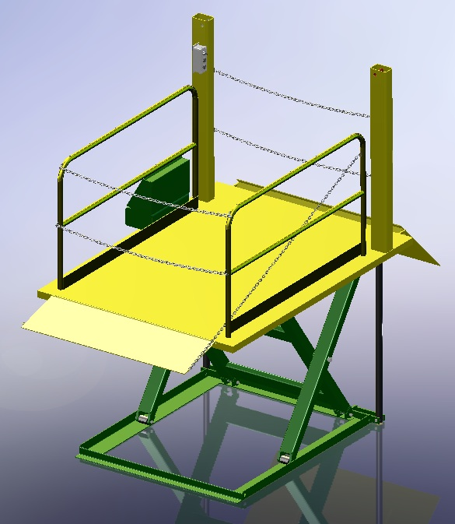

Southworth Surface Mount Dock Lift Installation

- Ensure the area the Surface Mount Dock Lift will sit on is flat and level.
- Remove the shipping material.
- Remove the lift from the skid and set in place.
- The power unit is prewired from the factory and will only need the proper voltage supplied. If three phase a fused disconnect will need to be supplied by the customer and proper wiring done from the disconnect to the control panel.
- Once the lift is in position and properly set up electrically, the lift is now ready to be powered up. The hydraulic system has been installed and plumbed at the factory.
- If the lift is equipped with lag plates lag the lift down. If a portability kit is supplied ignore this step.
- Cycle the lift and inspect.
- Cleaned any debris; wipe up any oil and ensure all operators are fully trained on the operation of the lift.

